

High Level Requirement

Sabre 2.0 - Product Catalogue

# Contents

Contents

1 Contents 2

3 Executive Summary 3

3.1 Purpose of document 3

3.2 High level outline of solution and business benefit 3

4 Document Control 4

4.1 Versioning 4

4.2 Reviewing information 4

4.3 Review history 4

5 Managing Products Catalogue (Nominal) 5

5.1 UK Sales Channel 5

5.1.1 Requirement statement 5

5.1.2 Requirement scenarios 5

5.2 Product Catalogues 5

5.2.1 Requirement statement 5

5.2.2 Requirement scenarios 5

5.3 Product Categories 5

5.3.1 Requirement statement 5

5.3.2 Requirement scenarios 5

5.4 Product Properties / Filters 5

5.4.1 Requirement statement 5

5.4.2 Requirement scenarios 5

5.5 Product lifecycle 5

5.5.1 Requirement statement 5

5.5.2 Requirement scenarios 5

5.6 Search Products 7

5.6.1 Requirement statement 7

5.6.2 Requirement scenarios 7

5.7 Free of Charge Products 7

5.7.1 Requirement statement 7

5.7.2 Requirement scenarios 8

5.8 Product variants 8

5.8.1 Requirement statement 8

5.8.2 Requirement scenarios 8

5.9 Product versions 8

5.9.1 Requirement statement 8

5.9.2 Requirement scenarios 8

5.10 Bundles (including hidden) 9

5.10.1 Requirement statement 9

5.10.2 Requirement scenarios 9

5.11 PDPs (Product Description Pages) 10

5.11.1 Requirement statement 10

5.11.2 Requirement scenarios 10

5.12 Pricing Rules Engine 10

5.12.1 Requirement statement 10

5.12.2 Requirement scenarios 10

6 Additional functionalities (Readiness) 12

6.1 EPP – Partners and Staff Channel 12

6.1.1 Requirement statement 12

6.1.2 Requirement scenarios 12

6.2 Vouchers 12

6.2.1 Requirement statement 12

6.2.2 Requirement scenarios 12

6.3 Tagging Support 13

6.3.1 Requirement statement 13

6.3.2 Requirement scenarios 13

6.4 Ratings & Reviews 13

6.4.1 Requirement statement 13

6.4.2 Requirement scenarios 13

6.5 Product Accessories 13

6.5.1 Requirement statement 13

6.5.2 Requirement scenarios 14

6.6 Scheduling 15

6.6.1 Requirement statement 15

6.6.2 Requirement scenarios 15

6.7 Cloning Products 15

6.7.1 Requirement statement 15

6.7.2 Requirements scenarios 15

6.8 Services 16

6.8.1 Requirement statement 16

6.8.2 Requirement scenarios 16

6.9 Audit 16

6.9.1 Requirement statement 16

6.9.2 Requirement scenarios 16

7 Requirement Specification: Generic 16

7.1 Generic requirements 16

7.1.1 Requirement statement 16

7.1.2 Requirement scenarios 16

7.2 System integration 17

7.2.1 Requirement statement 17

7.2.2 Requirement scenarios 17

8 Glossary 18

9 Data Confidentiality Statement for this document 19

9.1 Confidentiality Policy 19

9.2 Intended audience 20

9.3 Intended audience audit 20

# Executive Summary

## Purpose of document

This document contains the requirements for the Sabre 2.0 project Product Catalogue, the requirements will be outlined from a business perspective and will not contain any technical details; this document will enable a clear understanding of the requirements to be obtained by all of the project team, and therefore enable a project impact assessment to be completed, and the project to be estimated, but it won’t contain all of the detailed requirements for the solution – these will be discussed and agreed during the development phase of the project.

## High level outline of solution and business benefit

The Sabre 2.0 Product Catalogue application enables the client administrators to manage the data and lifecycle of products and related information. The Sabre 2.0 Product Catalogue supplies the product information to various systems e.g. Order Processing etc. There is an admin interface to enable the information to be viewed, amended and managed.

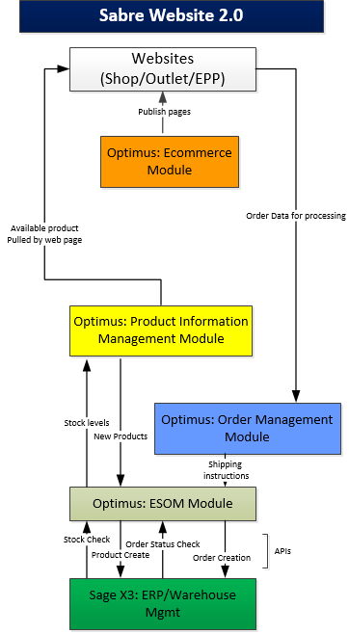

Figure 1: High level diagram of the Product Catalogue application

# Document Control

## Versioning

|  |  |  |  |  |
| --- | --- | --- | --- | --- |
| Ver. # | Change Description | Release Reference | Date | Author |
| 0.1 | Gathering requirements | 1.0 | 11/02/16 | AR |
| 0.2 | Updated requirements specifications based on internal review | 1.0 | 15/02/16 | AR |
| 0.3 | Updated requirements based on Salvador review | 1.0 | 16/02/16 | AR |
| 0.4 | Added sections 5.7 - 5.11 | 1.0 | 17/02/16 | AR |

## Reviewing information

|  |  |  |
| --- | --- | --- |
| Document Owner (BA) | Alin Radu | AR |
| Project Manager | Tom Freemantle | TF |
| Product Owner | David McLean | DM |
| Project Sponsor | Simon Trend | ST |
| Platform Development | Ozkan Mustafa | OM |
| Customer Services | Taz Rose | TR |
| Head of Sales | Brigid Cerelli | BC |
| Infrastructure | Razvan Draghichi | RD |

## Review history

|  |  |  |
| --- | --- | --- |
| Document Ver. # | Reviewers | Sign off status |
| 1.0 | Simon Trend |  |
| 1.0 | David McLean |  |
| 1.0 | Ozkan Mustafa |  |
|  |  |  |

# Managing Products Catalogue (Nominal)

## UK Sales Channel

### Requirement statement

The Product Catalogue application enables an administrator to set special prices or set visibility for products based on group of customers. These are grouped together in channels.

Main Sales Channel for Sabre is UK.

### Requirement scenarios

1. The administrator can associate products (offerings, product versions and product variants) or product bundles to a specific channel.
2. The administrator can price differently the products or product bundles for different channels.

#### SUK – Samsung UK

SUK is the controlling region for the following: SST, SEP (Partners and Staff).

This is the main website where unregistered customers view the offerings online - http://shop.samsung.com/uk/

## Product Catalogues

### Requirement statement

### Requirement scenarios

## Product Categories

### Requirement statement

### Requirement scenarios

## Product Properties / Filters

### Requirement statement

### Requirement scenarios

## Product lifecycle

### Requirement statement

The Product Catalogue application enables an administrator to manage a product through its lifecycle from creation, to publication to a sales channel through to managing the discontinued process.

### Requirement scenarios

The steps a product goes through are:

1. Create a product
2. Add details for a product
3. Price product
4. Publish a product
5. Unpublish a product
6. Discontinue a product.
7. Remove a product

#### Creation

A product can be created in the following ways:

* 1. Created in the Product Catalogue application (and pushed to the ERP)
  2. Details pulled to the Product Catalogue application from an ERP or API system.

#### SKUs

Manufacturer’s SKU code will be used as main identifier across platforms.

It is Sabre’s responsibility to provide SKU for each product in Product Catalogue.

#### Validation

If the product is created in the Product Catalogue then the details are validated and pushed to the ERP in order for supplier orders to be created and logged in the necessary system.

1. Validation steps include ensuring that a duplicate product is not created (i.e. an identical product, rather than one creating for cloning for variants or bundling purposes).
2. If the ERP creates the product then the details are pulled from the ERP by the Product Catalogue, ensuring the Product Catalogue is kept up to date with available stock. There is an administrator screen for the Product Manager to select which products to add.

#### Details

Basic product details include: Product type, Properties, Product id, Product label etc.

Each product can be associated to single/multiple catalogues, categories.

#### Price

An administrator can add a sale price for a product. This includes viewing supplier/purchase price information, and adding the sales price;

It is Sabre’s responsibility to provide prices for each SKU;

Pricing should be regularly updated by Sabre, whether for promotions or for BAU.

An administrator can create different prices for product, product variant, product version or product bundle for all product types.

Product Catalogue should permit administrator to set prices to:

* 1. Always end in a set decimal figure i.e. 1.99 e.g. 1.99
  2. Always end in a set single figure i.e. 9 e.g. 589, 239.
  3. Always end in a set double figure i.e. 99 e.g. 599, 299.

#### Pre-Orders

Administrator can set in Product Catalogue an optional date and time when a product will be available for pre-order.

#### Trade-ins

Product catalogue should have a field/checkbox to highlight if a product can be purchased with Trade-in discount.

#### Publish/Unpublish

A new product, or changes to an existing product, can be published to a sales channel. A product can be withdrawn (or unpublished) from a sales channel. There are specific business rules and procedures in places for withdrawing a product, as this occurs immediately.

#### Discontinue/Remove

A product can be discontinued; this can affect pricing, and also results in the product being unpublished when the last product is sold.

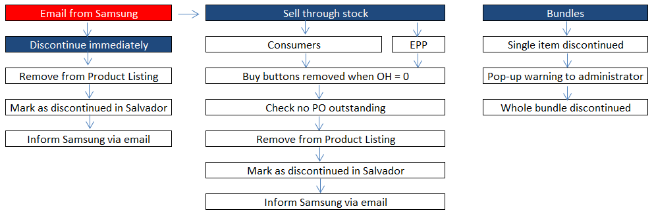

Figure 2 Sabre Discontinue End of Life Flow

## Search Products

### Requirement statement

An administrator should be able to search for products across catalogues within the Product Catalogue tool.

### Requirement scenarios

Search should be available by make, manufacturer with full or partial match.

Also administrator has option to limit or broaden the search to Bundles, Accessories or specific categories/catalogues.

## Free of Charge Products

### Requirement statement

A number of Free of Charge (FOC) products that Sabre has shipped from HQ appear unannounced from time to time. These are to be treated with an “as-and-when” approach; SKUs need to be provided by Sabre. These represent campaigns & marketing materials.

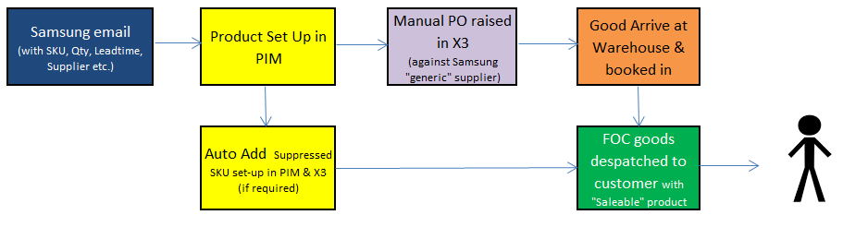

Figure 3 Process to set up and order FOC products

### Requirement scenarios

1. Examples of FOC SKUs:
   * + MONTBLANC-CASE
     + MONTBLANC-PEN
     + VISIONAIRE64ARTJB

## Product variants

### Requirement statement

An administrator can create multiple variants of a product. A variant enable one or more key features of a product to be different, but the product variants to be linked e.g. sizes for clothes, or color for a device.

### Requirement scenarios

1. The key features which can be part of the variant can be specified by the administration e.g. size, colour etc. This is based upon the fields for a product.
2. The administrator can create a product variant template by product type.
3. The administrator can add the information for the different variants, this can be more than one key feature for a product type e.g. colour and size for the clothes.
4. Each variant produced has a different SKU.
5. Each variant can have a different price; if no price is specified for the variant the price for the product is used.
6. The administrator has the option to specify a default product variant; this can be used to determine the default variant of a product displayed on a product listing and detail page.

## Product versions

### Requirement statement

An administrator can create multiple versions of a product. A version of a product enables a single product with the same core information to have different information published e.g. different information for A-B testing in the detailed section; add to different catalogues with different information for marketing purposes etc.

### Requirement scenarios

1. An administrator can create multiple product versions and associated with multiple product categories and sub-categories (used for searching and filtering).
2. The administrator can view and filter by product version name, product type and other key fields, and also filter by archive or non-archived status.
3. The product version consists of:
   1. Product details e.g. product name, make, SKU, colour etc.
   2. Product images
4. The administrator can also add additional optional custom fields which can be used against all products, or against a specific product category.
5. Note: pricing of products version is detailed below separately.
6. The product version is linked to the main product.
7. A product template can be created which defines the specific fields which are used for a product version. This enables the same information to be easily entered for each product of a similar type that is added.

## Bundles (including hidden)

### Requirement statement

An administrator can add bundles. A bundle is products of any types grouped together for sale purposes. There are two types of bundles: visible bundles and hidden bundles. Visible bundles are shown to the end customer through the sales channel. Hidden bundles are not visible to the end customer, and are used for pick and pack purposes e.g. picking up a device and a plug.

### Requirement scenarios

1. An administrator can create two types of items within a bundle: visible items and hidden items.
2. A bundle can include a mixture of hidden and visible items.
3. A visible item is one which is displayed to the end customer through the sales channel e.g. purchase X product and Y and Z products come as part of the package. All products in a visible bundle are provided to the sales channel.
4. A hidden items is one which doesn’t show to an end customer, but is used as part of the pick and pack process. Details of the hidden products are provided to the sales channel and order systems etc. with a flag to indicate that it needs to be displayed or managed differently.
5. A bundle has a specific SKU.
6. A bundle has a specific sales price;
7. The Product Catalogue supports any product type or version being bundled together; if specific business rules are required for bundles for a sales channel then these would be managed through a client extension (during implementation) – as it would impact other systems.
8. The administrator can specify the primary product for a bundle.
9. The administrator can specify these items specifically for the bundle:
   1. The bundle details, images etc. can be duplicated from the primary product for the administrator to then edit.
   2. Bundle details e.g. product name, make, SKU, colour etc.
   3. Bundle description including rich content e.g. HTML formatted description with links to videos
   4. Bundle images and links to videos
10. The administrator can also add up to 50 additional optional custom fields which can be used against all bundles, bundle template, or against a specific bundle type.
11. A bundle template can be created which defines the specific fields which are used for a product. This enables the same information to be easily entered for each bundle of a similar type that is added.

## PDPs (Product Description Pages)

### Requirement statement

Products Details page should be hosted on the same platform. Product catalogue should be able to provide all the necessary information to be displayed in the PDPs.

### Requirement scenarios

1. Current platform redirects customers to Samsung.com PDP, but going forward with the new platform customer will stay on the same domain as the UK Shop homepage and product listing.
2. Examples of this are bundles created by eXpansys (XPS) for promotional activities. For example: <http://shop.samsung.com/uk/samsung-galaxy-s6-edge-visionaire-limited-edition-art-bundle-128gb-black-285964/> .

# Additional functionalities (Readiness)

## EPP – Partners and Staff Channel

### Requirement statement

An administrator can add a sale price for a product. This includes viewing supplier/purchase price information, and adding the sales price. Sale pricing can be a fixed price or a percentage of the purchase price, or based upon margins of the purchase price etc.

### Requirement scenarios

The EPP sites are a part of the main shop.samsung.com, but you require a login in order to be able to access them. The product catalogue is supposedly different from the main shop.samsung.com. Below are relevant categories and discounts:

1. S6 mobile – 10% off
2. All other Mobile – 15% off
3. Tablet – 15% off (with exception of TabS for first 2 weeks)
4. TV/AV – 10% off
5. DA – 15% off
6. Monitor/Printer – 10% off
7. Gear Watches – 20% off

Partners receive the EPP login URL with a verification code which they use to login with their Samsung account details (http://shop.samsung.com/uk-epp/)

There are the following differences with EPP sites to the normal one:

* 1. Unique Pricing
  2. Unique Channels
     1. SEP
     2. SST

1. All other aspects remain identical to shop.samsung.com

## Vouchers

### Requirement statement

An administrator can add discounts for a product, i.e. vouchers.

### Requirement scenarios

1. An administrator can create a single voucher or specific quantity of vouchers with the same rules.
2. An administrator can specify the business rules for a voucher e.g. sales channel, catalogue, product category or product(s)/bundle(s) applicable.
3. Vouchers can be either:
   1. Fixed price e.g. £50 off an order
   2. Percentage e.g. 5% off an order
4. Business rules can be created for a voucher e.g. only applies if basket above X or below Y.
5. Product types that vouchers are linked with can be any type e.g. product, service (e.g. delivery) etc. or can span multiple product types.
6. Voucher codes can be randomly generated, or a friendly code – to support the different ways they are marketed.
7. Vouchers can be an active period e.g. from X date to Y date.
8. Voucher templates can be created, to enable vouchers to be easily created with the same business rules.

## Tagging Support

### Requirement statement

An administrator can tag a product so that online channels analytic reporting system e.g. Google Analytics and/or Omniture can identify the product.

### Requirement scenarios

1. An administrator can associate a tag with a product, or product bundle.
2. Currently Short SKU is also used as identifier analytic tracking (Omniture, Basket Abandonment, Sales, etc).
   1. This is generally the beginning of the Sabre SKU, excluding any product variation (Colour, Size etc);
   2. Example: SM-G925 (Galaxy S6 edge);
   3. This is to be provided by Sabre.

## Ratings & Reviews

### Requirement statement

Consumer ratings and reviews are received from Sabre system. These need to be stored and viewed in Product Information Management tool.

### Requirement scenarios

1. When the product is published, the website will display the correct information from Product Information Management.
2. Ratings and reviews are transmitted by API from Sabre.
3. Ratings and reviews are view-only in Product Catalogue.

## Product Accessories

### Requirement statement

An administrator can map primary and regular accessories to physical products in the product catalogue tool. Primary accessories are “model specific”, while the regular accessories are ““generic / universal”. Sabre does not currently provide a compatibility matrix, but do list primary accessories related to each model.

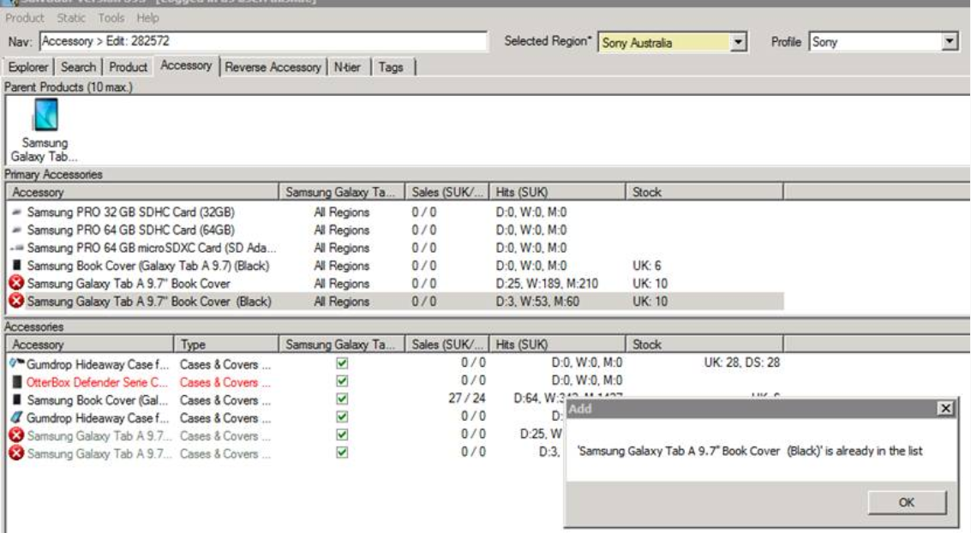

### Requirement scenarios

1. The administrator can link accessories for a specific product from the product details page from Product Catalogue tool. Primary accessory items will be manually copied to other phone variants as well (i.e. Samsung S6 has 4 colours / 3 mem sizes).
2. For adding regular accessories (by reverse mapping), we should be able to add an ‘Accessory Master’ sku in other phone variant SKUs, so all reverse mapped accessories to that phone accessory master sku will replicate the mapping to other phone variants.

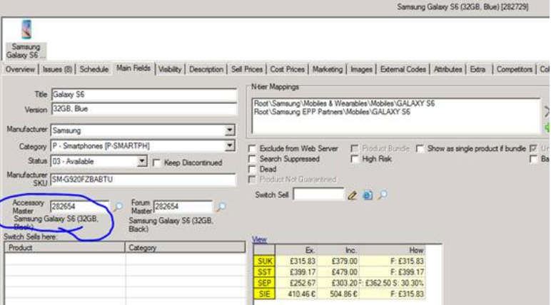

1. You can only add a product to the primary accessories list if it is already a regular accessory.
2. All accessories need to have an accessory type (i.e. Car Kits, Controllers, Cases and Covers, etc.)

## Scheduling

### Requirement statement

An administrator can configure price changes and these changes will appear on the website with a delay that can be edited.

### Requirement scenarios

1. The Schedule functionality effectively delays when the price changes are published on the website;
2. Times are UK;
3. 00:00 is at the beginning of a day;
4. Administrator should be able to edit or cancel a scheduled change;
5. Current platform does not unable administrator to schedule changes to go back to their previous state. E.G, to raise a price back to its RRP after a discounted price has been scheduled.

## Cloning Products

### Requirement statement

An administrator should be able to clone products in the Product Catalogue application. This functionality will eliminate the manual error and also reduce the time of adding new products in similar categories.

### Requirements scenarios

* + - 1. Administrator should be able to clone all details, images, accessories of a product, excluding the SKU code.

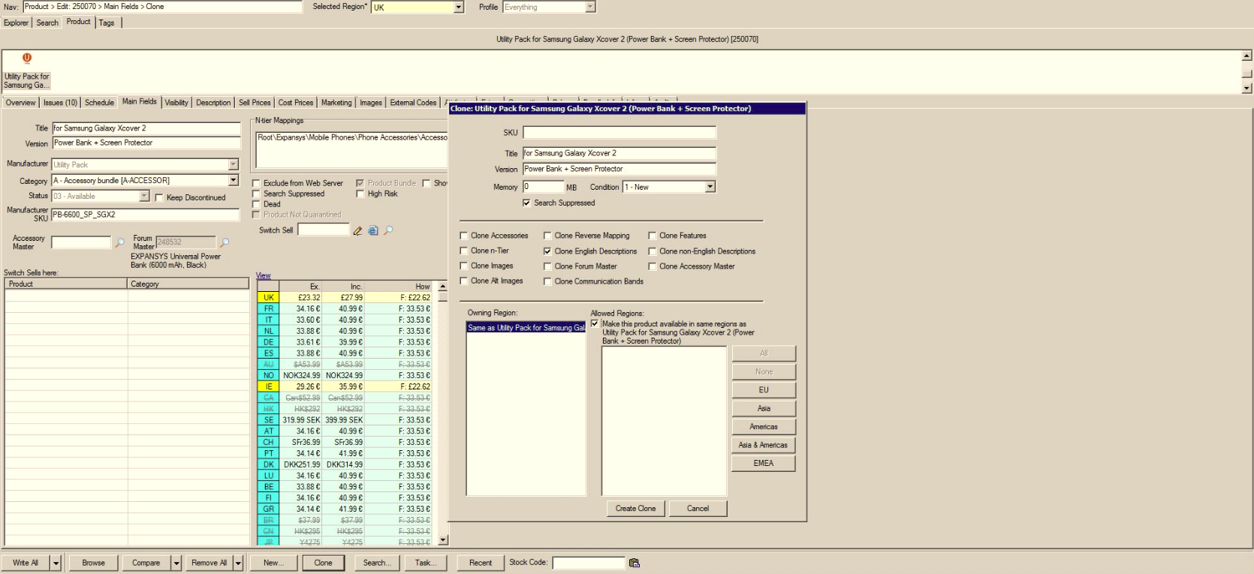

## Services

### Requirement statement

The Product Catalogue application enables an administrator to create a service product e.g. delivery of a product by a courier company. - OOS

### Requirement scenarios

1. An administrator can create service types, and associate with service type(s).
2. An administrator can create a service product.
3. The administrator can view and filter by service name, service type and other key fields, and also filter by archive or non-archived status.
4. The service consists of:
   1. Service details e.g. service name, service code, duration, SKU etc.
   2. Service inclusions e.g. free support etc.
   3. Service duration e.g. first day it’s available for sale, or last day it’s available for sale.
   4. Service images (used to display in promotions etc.)
5. The administrator can also add up to 50 additional optional custom fields which can be used against all service products, service template, or against a specific service type.
6. A product template can be created which defines the specific fields which are used for a product. This enables the same information to be easily entered for each product of a similar type that is added.
7. Note pricing of services is detailed below separately in requirement 4.13Pricing Rules Engine.

## Audit

### Requirement statement

Product catalogue tool should register actions taken against a product for audit purposes.

### Requirement scenarios

Audit section is required to facilitate supervision and monitoring, prevent and detect irregular transactions or changes to offerings.

Currently, in Salvador, this section does not register history of actions.

# Requirement Specification: Generic

## Generic requirements

### Requirement statement

The Product Catalogue application will adhere to the generic Optimus requirements (see separate HLR).

### Requirement scenarios

1. The following generic requirements are supported:
   1. Multi-region
   2. UK Pounds is the currency set for Sabre 2.0 project.
   3. Omni-channel
   4. Multi-tenanted
   5. Multi-site
   6. Operational information
   7. Audit logging
   8. Sales tax
2. The system will be monitored, as per:
   1. System health check
   2. System alerts
3. The system will support reporting, as per:
   1. Operational information
   2. Strategic reporting
4. The following generic requirements are not supported:
   1. Multi-device
   2. Multi-currency

## System integration

### Requirement statement

The Product Catalogue application will be integrated with the other systems to both obtain information and to be able to send information to enable the business processes to be completed.

### Requirement scenarios

1. The Product Catalogue application integrates with the following systems:
   1. eCommerce core – for publishing products, prices and vouchers.
   2. shop.samsung.com website – Make product information available to be displayed to the end customer.
   3. Stock orchestration module– for information on stock levels.
   4. Order processing– for providing details of products and vouchers in an order.
   5. ERP– for providing and obtaining product information.
   6. SSO – for managing login, as specified in detail below.
2. The system integration feeds & services are monitored to ensure that the services, availability and the data is being received and sent correctly, and without issue.

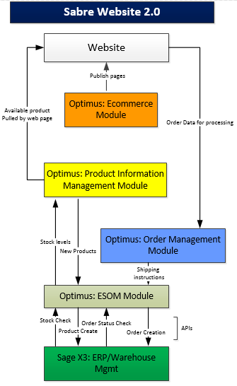

# Glossary

| **Term** | **Description** |
| --- | --- |
| Back order |  |
| Bundle |  |
| catalogue |  |
| Channel |  |
| Client |  |
| Comms Module |  |
| Customer |  |
| eCommerce core |  |
| ePos |  |
| ERP |  |
| Fraud Management |  |
| Fulfilment (payment) |  |
| Hidden bundle |  |
| Logistics status |  |
| Middleware |  |
| Operational reporting |  |
| Order Processing Administrator |  |
| Order Workflow Step |  |
| payment gateway |  |
| Physical product |  |
| Pick and pack |  |
| Post-paid |  |
| Pre-auth |  |
| Pre-paid |  |
| Price Plan |  |
| Product |  |
| Product Catalogue application |  |
| Product variant |  |
| Product version |  |
| Region |  |
| Service |  |
| Shipment |  |
| Stock |  |
| Stock Orchestration Module |  |
| Strategic reporting |  |
| System Administrator |  |
| Tagging |  |
| Visible bundle |  |
| Voucher |  |

# Data Confidentiality Statement for this document

## Confidentiality Policy

This data confidentiality policy is intended to:

* Protect sensitive company data
* Support the communication of company data on a ‘need to know basis’

This policy is applicable to all information within and relating to the **High Level Requirement: Sabre 2.0 Product Catalogue**. Failure to comply with the policy may place the EXPANSYS group companies and subsidiaries, suppliers and clients at serious risk and/or result in financial loss. Failure to comply with the policy when handling data may be considered a disciplinary offence.

This Policy applies equally to EXPANSYS, PJ Media Limited, PJ Interactive, and Data Select.

The confidentiality level of this document has been determined as Category 1 – Critical: This data, if lost or published outside of its intended audience will result in significant financial loss or reduction in the company’s ability to execute its mission. The audience for this document is limited to those listed below.

The business owner for the High Level Requirements: Sabre 2.0 Product Catalogue is Alin Radu; all queries relating to the confidentiality should be directed to this person.

## Intended audience

| **Company** | **Role** | **Name** |
| --- | --- | --- |
| **[Company]** | **[role of document owner]** | **[name]** |
| PJ Media Limited | Business Analyst | Alin Radu |
| PJ Media Limited | Business Analyst | Gary Challoner |
| PJ Media Limited | Project Manager | Tom Freemantle |
| PJ Media Limited | Product Owner | David McLean |
| PJ Media Limited | Project Sponsor | Simon Trend |
| PJ Media Limited | Platform Development | Ozkan Mustafa |
| PJ Media Limited | Customer Services | Taz Rose |
| PJ Media Limited | Head of Sales | Brigid Cerelli |
| PJ Media Limited | Infrastructure | Razvan Draghichi |

## Intended audience audit

| **Version #** | **Change Description** | **Date** | **Author** |
| --- | --- | --- | --- |
| 0.1 | Created intended audience | 15/02/16 | Alin Radu |